|  |
| --- |
| **NAAN MUDHALVAN**  **DIGITAL MARKETING**  **Participants:**   1. Surya M ( au913120104101) 2. Abishek kumar M S (au913120104004) 3. Siva Kumar R (au913120104307) 4. Srekaravarshan N K (au913120104094) |

**PROJECT – 9**

**Instagram Reel**

**Create an Instagram reel for your business brand and promote it attract a minimum of 100 Likes**

**Aim:**

To create an Instagram reel for our business brand and promote it attract a minimum of 100 likes.

**Procedure:**

**Industry Selection:**

* Research and identify the target audience and niche within the industry. Consider factors like gender, age group, sports focus, or unique selling points.
* Choose a brand name that resonates with your niche, is easy to remember, and has an available domain name for a future website **Creating an Email ID:**
* Select an email service provider like Gmail, Yahoo, or Outlook.
* Visit the chosen provider's website.

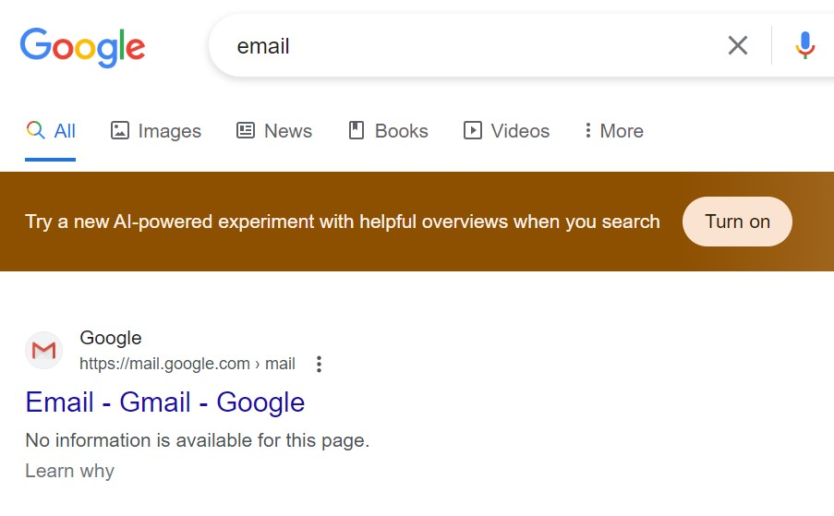

* Click on "Sign Up" or "Create Account."

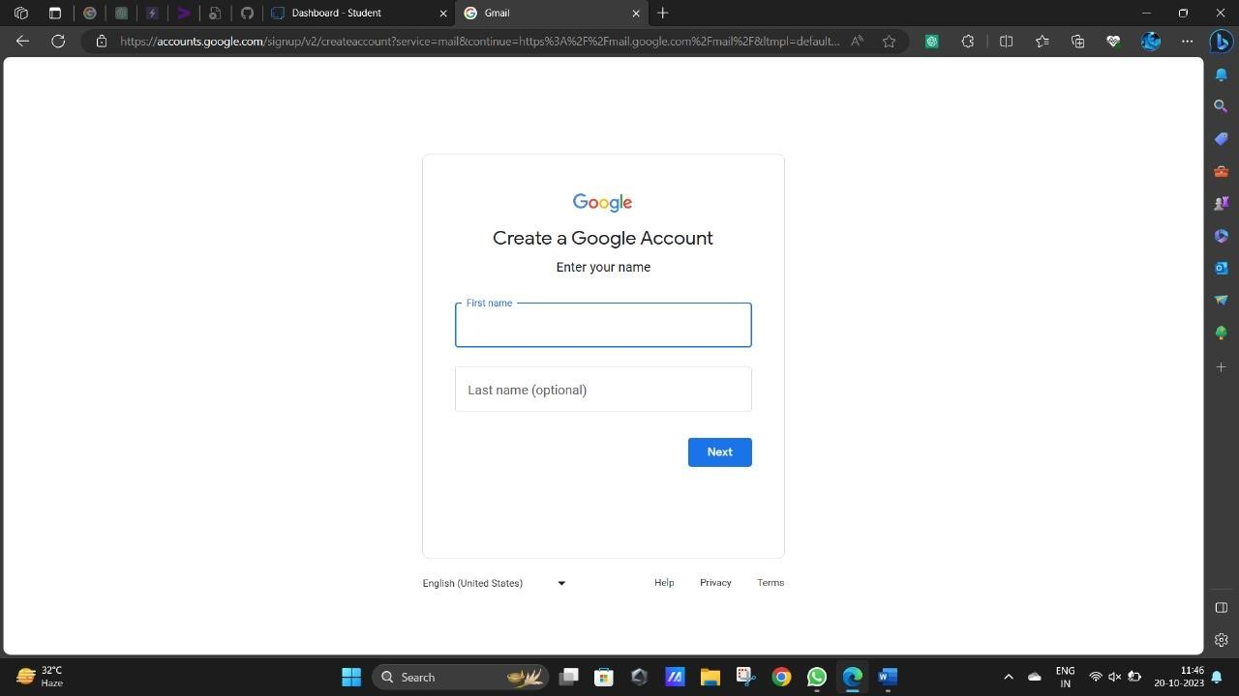

* Fill in your personal information, including your name and preferred email address.

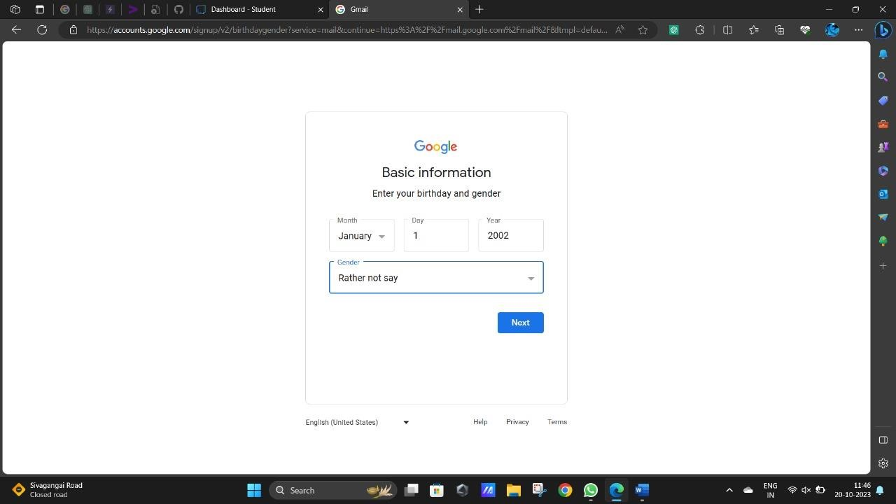

* Set a secure password.
* Verify your identity through a verification code sent to your phone or another email address.

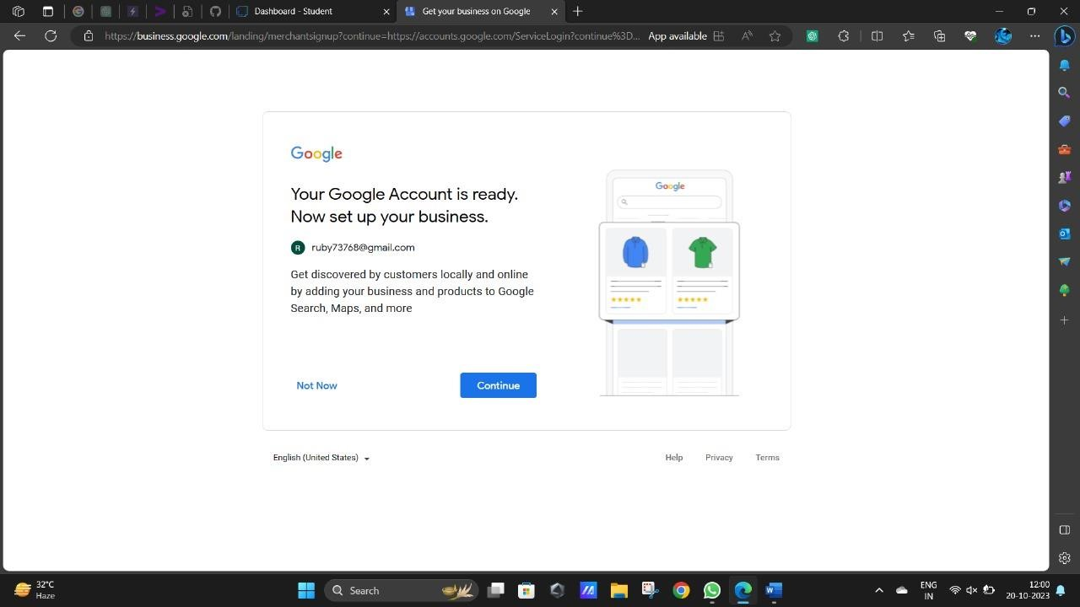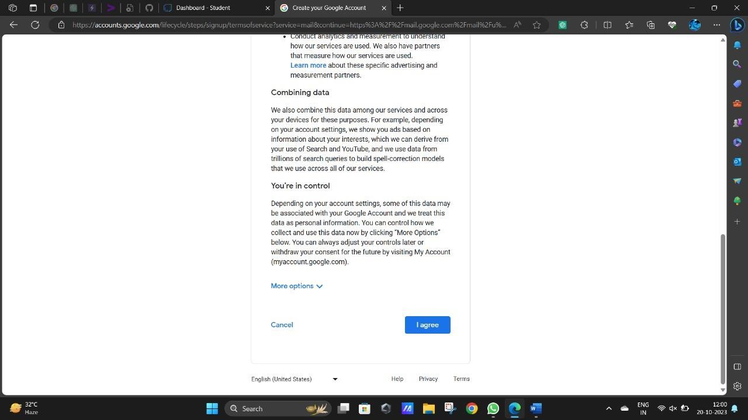

* Your email account is now created.

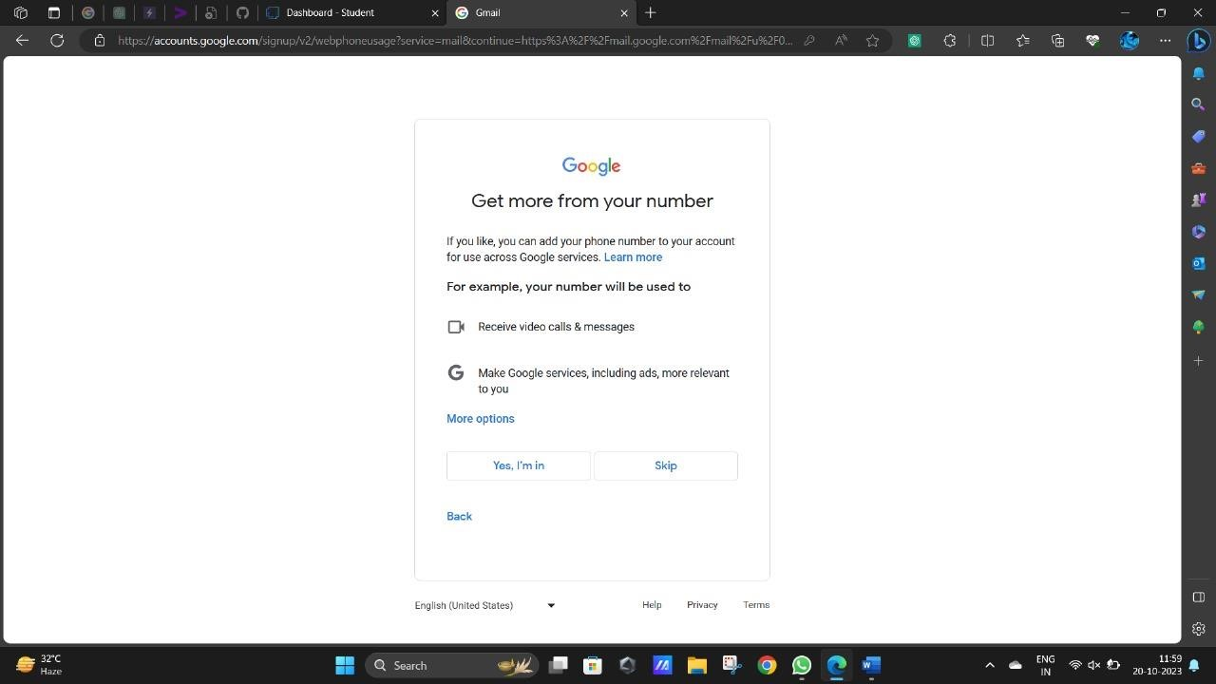

**Designing a Logo**

* Create a logo that reflects the brand's identity, values, and target audience.
* Choose a color palette that aligns with your brand and industry.
* Ensure the logo is versatile and looks good in various sizes and formats.

**Creating an Instagram Page** • Download the Instagram app from your smartphone's app store.

* Open the app/website.

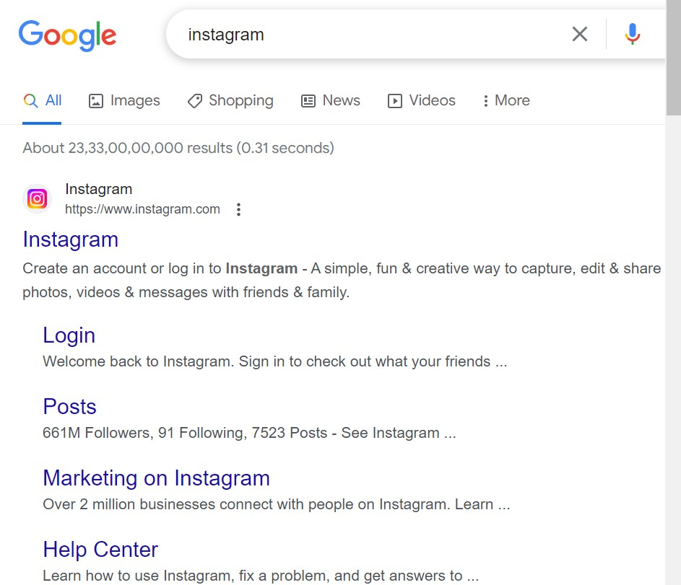

* Sign up for a new account using your brand's name, a profile picture (use your logo), and a bio that describes your athletic wear brand.

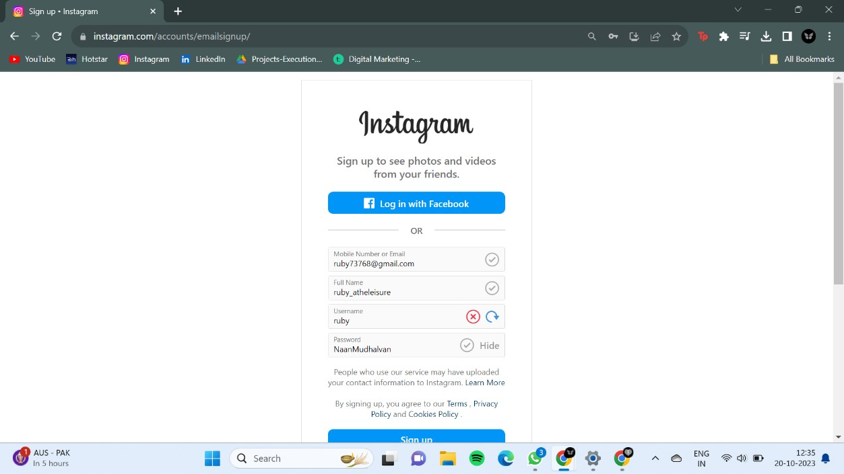

* Make your account public.

**Designing a reel**:

* Open canva

* Choose a template

* Fetch stock videos

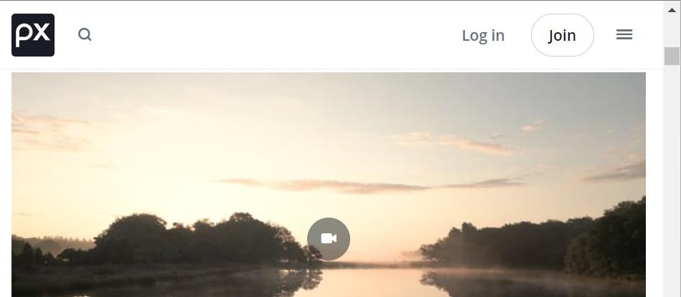

* Design a reel

**Uploading in Instagram:**

**Result**:

* **Email Id:** [msurya1459@gmail.com](mailto:msurya1459@gmail.com)

➢ **Industry Name:** ASCUBE

* **Industry Type:** Fashion Wears
* **Instagram Id:** as3_clothing_store

➢ **Instagram Reel:** [AS Cube (@as3_clothing_store) • Instagram photos and videos](https://www.instagram.com/reel/Cy20tbLp86f/)

➢**DriveLink:** [**https://drive.google.com/drive/folders/1SUOOZUDQGXPtFN-elKhC0jJtSkk0QFB4?usp=sharing**](https://drive.google.com/drive/folders/1SUOOZUDQGXPtFN-elKhC0jJtSkk0QFB4?usp=sharing)